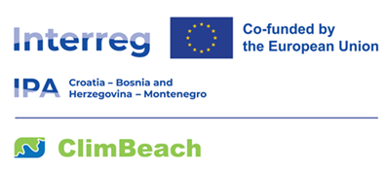

Photogrammetric Survey and Volumetric Change Analysis of Pilot Beaches in Montenegro

CLIMBEACH T06

Public Enterprise for Coastal Zone Management of Montenegro intends to award a service contract for Photogrammetric survey and volumetric change analysis of six pilot beaches in Montenegro in Budva with financial assistance from the INTERREG IPA CBC Programme Croatia-Bosnia and Herzegovina-Montenegro, 2021-2027.
The tender dossier is available from:
https://www.morskodobro.me/me/javne-nabavke/eobavjestenja

The deadline for submission of tenders is the 17 April 2026 at 16:00 (local time).
Possible additional information or clarifications/questions shall be published on the website of the Contracting Authority at
https://www.morskodobro.me/me/javne-nabavke/eobavjestenja

