ANNEX II: TERMS OF REFERENCE
Ref: CLIMBEACH T06
Photogrammetric Survey and Volumetric Change Analysis of Pilot Beaches in Montenegro, Budva, Montenegro
1. BACKGROUND INFORMATION 2
1.1. Partner country 2
1.2. Contracting authority 2
1.3. Country background 2
1.4. Current situation in the sector 2
1.5. Related programmes and other donor activities 2
2. OBJECTIVES & EXPECTED OUTPUTS 2
2.1. Overall objective 3
2.2. Specific objective(s) 3
2.3. Expected outputs to be achieved by the contractor 3
3. ASSUMPTIONS & RISKS 4
3.1. Assumptions underlying the project 4
3.2. Risks 4
4. SCOPE OF THE WORK 4
4.1. General 4
4.2. Specific work 4
4.3. Project management 5
5. LOGISTICS AND TIMING 5
5.1. Location 5
5.2. Start date & period of implementation of tasks 5
6. REQUIREMENTS 5
6.1. Personnel 5
6.2. Office accommodation 6
6.3. Facilities to be provided by the contractor 6
6.4. Equipment 7
7. REPORTS 7
7.1. Reporting requirements 7
7.2. Submission and approval of reports 7
8. MONITORING AND EVALUATION 8
8.1. Definition of indicators 8
8.2. Special requirements 8

BACKGROUND INFORMATION

Partner country
Montenegro

Contracting authority
Public Enterprise for Coastal Zone Management of Montenegro
(Javno preduzeće za upravljanje morskim dobrom Crne Gore – JPMD)
Popa Jola Zeca bb, 85310 Budva, Montenegro

Country background
Coastal areas of the programme region are highly dependent on beaches that are increasingly exposed to adverse impacts of climate change, particularly through the growing frequency and intensity of wave action generated by wind and sea level rise, resulting in coastal flooding and reduction of available beach areas for recreation, sports and tourism. Wind-generated waves also have a destructive impact on beach sediments, causing erosion and gradual loss of beaches. Therefore, the objective of the ClimBeach project (Improving Coastal Areas Resilience to Climate Change Impacts and setting up Guidelines for Sustainable Beach Stabilization and Management), implemented under the Interreg VI-A Croatia – Bosnia and Herzegovina – Montenegro 2021–2027 Programme (hereinafter: ClimBeach), is to develop an integrated multi-physical and multi-technological solution aimed at reducing negative impacts of climate change on beach areas and increasing beach resilience to erosion and flooding.

Current situation in the sector
Coastal areas in the programme region rely heavily on beaches for recreation, sport and tourism. These beaches are increasingly exposed to the adverse effects of climate change, in particular: (i) sea level rise and (ii) more frequent and more intense wind-driven waves and extreme weather events, resulting in coastal flooding, sediment loss, erosion and gradual reduction of usable beach area.
In this context, there is a need for systematic, repeatable and high-resolution monitoring of beach morphology and shoreline change in order to:
- quantify erosion/accretion trends and volumetric changes of beach sediments;
- support assessment of vulnerability of coastal sectors;
- provide evidence to inform mitigation/adaptation measures and future beach stabilisation and management guidelines.

Related programmes and other donor activities
This project will be implemented in compliance with the INTERREG IPA CBC Croatia-Bosna and Herzegovina-Montenegro 2021-2027 Programme rules.

OBJECTIVES & EXPECTED OUTPUTS
This public procurement procedure relates exclusively to six (6) pilot locations in Montenegro, while the remaining pilot locations are situated in Croatia and Bosnia and Herzegovina, fall under the responsibility of other project partners, and are implemented through separate procurement procedures. The monitoring plan is designed to ensure a systematic analysis of key parameters affecting beach dynamics, including sediment transport, erosion processes, and the impacts of extreme weather events. The data obtained will enable an assessment of the vulnerability of individual coastal sectors, identification of change trends, and the development of effective measures to mitigate the impacts of climate change on coastal areas.
With regard to alignment of these Terms of Reference with the project activities under Improving Coastal Areas Resilience to Climate Change Impacts and Setting up Guidelines for Sustainable Beach Stabilization and Management, the implementation and execution of monitoring activities are envisaged to track changes in beach volumetrics in accordance with project activity A1.4: In-situ beach dynamics monitoring implementation in pilot sites.
In terms of compliance with A1.4, these Terms of Reference are aligned with project deliverable D.1.4.1: Report on the monitoring activities in CR, BiH and MN, which will include a comprehensive overview of monitoring activities carried out in Croatia, Bosnia and Herzegovina, and Montenegro, together with infrastructure data and results. Furthermore, the implementation of the activities envisaged under these Terms of Reference will contribute to project deliverable D.1.4.2: Report on the beach dynamics monitoring in CR, BiH and MN, which will provide detailed information on beach dynamics monitoring performed during one (1) year of project implementation. Particular attention will be given to the onshore and offshore sediment components, as well as shoreline changes at locations in Croatia, Bosnia and Herzegovina, and Montenegro.
In - situ beach monitoring assumes local in time and dependent in - space monitoring of the shoreline change caused by change in volumetric of the sediment beach pilot site beach is made of. In accordance with the monitoring plan from A1.1., the beach monitoring will be performed prior and after the occasion of extreme meteorological and wave conditions, with wave heights and duration above the thresholds which will be determined based on the local features and existing data from the past. In this way, monitoring will enable real insight and relevant information about the impact of the tides and wind generated waves to coastal areas erosion and flooding. All pilot sites (12 in total) selected by the project will be covered by the shoreline monitoring which assumes for underwater sonar type scan and above seawater sediment remote sensing and photogrammetry post processing. The activity outputs will enable the knowledge on the effects of the seawater tides and waves to the beach erosion and flooding dynamics as a crucial input for the improvement of coastal resilience to climate change induced impacts.

Overall objective
The overall objective (Impact) to which this action contributes is :
To gain knowledge on the effects of the seawater tides and waves to the beach erosion and flooding dynamics as a crucial input for the improvement of coastal resilience to climate change induced impacts.

Specific objective(s)
The specific objective(s) (Outcome(s)) of this contract are as follows:
- Specific objective (Outcome) 1: To implement in-situ beach dynamics monitoring at the six (6) pilot beaches in Montenegro through repeated surveys over the contract period, including “before/after” monitoring in relation to extreme events where feasible.
- Specific objective (Outcome) 2: To produce comparable, georeferenced datasets and analyses enabling quantification of shoreline and sediment-volume changes per site and per epoch, in line with ClimBeach Activity A1.4 and related reporting requirements.

Expected outputs to be achieved by the contractor
The service will be paid on the basis of the delivery of the specified output(s). Payments might be totally or partially withheld if the contractual result(s) have not been reached in conformity with the detailed terms of reference. Payment(s) is/are based on the approval of this/these deliverable(s). Partial payment has to be determined according to the partial implementation of the output(s).
The expected outputs of this contract are as follows:
- Output 1 to Outcome 1: For each pilot site and each monitoring epoch, a classified point cloud delivered in .LAS format (including, as a minimum, terrain and relevant object/land-cover classes).
- Output 2 to Outcome 1: For each pilot site and each monitoring epoch, a Digital Terrain Model (DTM) derived from the terrain class, delivered in .LAS format.
- Output 3 to Outcome 1: For each pilot site and each monitoring epoch, a True Digital Orthophoto (TDO) delivered as georeferenced GeoTIFF (.tif).
- Output 4 to Outcome 2: Volumetric change analysis (erosion/accretion) between defined epochs, with results georeferenced and delivered in GIS-compatible digital format, including graphical annexes.
- Output 5 to Outcome 2: Monitoring report(s) presenting methodology, processing workflow, QA/QC and results, prepared for inclusion in ClimBeach reporting (one-year monitoring overview and monitoring activity reporting).

ASSUMPTIONS & RISKS

Assumptions underlying the project
- Access to the six pilot locations and permission to carry out required aerial and marine/nearshore survey activities will be ensured in a timely manner.
- Weather and sea-state conditions will allow execution of the planned survey epochs (including event-driven surveys when required).
- Stable and consistent georeferencing across epochs (agreed coordinate reference system, GNSS/control/check points and QA/QC) will be feasible, enabling reliable comparison of results.
- Efficient coordination and data exchange between the Contracting Authority, project team and Contractor will be maintained via agreed communication channels and a shared cloud repository.

Risks
- Adverse weather/sea conditions delaying fieldwork and limiting the ability to capture “before/after” event datasets.
- Administrative delays (e.g. authorisations for UAV operations and/or survey logistics).
- Technical risks (equipment malfunction, data loss, insufficient control/check point quality) affecting accuracy and comparability across epochs.
- Operational constraints at sites (restricted access, safety limitations, temporary infrastructure/activities on the beach) impacting survey execution.

SCOPE OF THE WORK

General

Description of the assignment
This public procurement procedure refers exclusively to six pilot locations in Montenegro, while the remaining pilot locations are located in Croatia and Bosnia and Herzegovina and fall under the responsibility of other project partners, implemented through separate procurement procedures. The monitoring plan is designed to ensure systematic analysis of key parameters affecting beach dynamics, including sediment transport, erosion processes and the impacts of extreme weather events. The collected data will enable assessment of vulnerability of individual coastal sectors, identification of change trends and development of effective measures to mitigate climate change impacts on coastal areas.
With regard to alignment of these Terms of Reference with project activities under the project Improving Coastal Areas Resilience to Climate Change Impacts and setting up Guidelines for Sustainable Beach Stabilization and Management, the implementation of monitoring activities aimed at tracking changes in beach volumetry is envisaged in accordance with project activity A 1.4 In-situ beach dynamics monitoring implementation in pilot sites.
In terms of alignment with Activity A 1.4, these Terms of Reference are aligned with project deliverable D.1.4.1 Report on the monitoring activities in CR, BiH and MN, which will contain a comprehensive overview of monitoring activities conducted in Croatia, Bosnia and Herzegovina and Montenegro, together with data on infrastructure and results. Furthermore, the implementation of activities foreseen by these Terms of Reference will contribute to deliverable D.1.4.2 Report on the beach dynamics monitoring in CR, BiH and MN, which will provide detailed information on beach dynamics monitoring carried out during one (1) year of project implementation. Special attention will be given to terrestrial and marine sediment components, as well as shoreline changes at locations in Croatia, Bosnia and Herzegovina and Montenegro.

Geographical area to be covered
The service relates to six selected pilot beaches in Montenegro.

Target groups
The target groups of this contract are:
- the Public Enterprise for Coastal Zone Management of Montenegro (JPMD) and other competent coastal management and planning institutions;
- ClimBeach project partners and technical teams responsible for in-situ beach dynamics monitoring and project deliverables (A1.4 / D.1.4.1 / D.1.4.2);
- local stakeholders/institutions involved in coastal protection, environmental monitoring and spatial planning, benefiting from improved evidence for decision-making.

Specific work
The service subject to procurement includes the implementation of multiple photogrammetric surveys from the air and underwater for the analysis of volumetric changes in coastal areas, data processing and delivery for each pilot location, and preparation of Reports. The service represents part of a comprehensive monitoring plan for a total of 12 pilot locations within the ClimBeach project, with the aim of establishing continuous monitoring of beach changes under the influence of natural and anthropogenic factors.

These Terms of Reference define the spatial, temporal, technological and capacity-related requirements necessary for the implementation of volumetric monitoring activities at beaches within 6 pilot areas in Montenegro.

Technical conditions for beach volumetric surveying

Within the scope of the service, photogrammetric aerial surveying of the supratidal (dry) part of the beach shall be carried out, covering the area up to which sedimentological beach features are visible, extending to the first continuous obstacle (vegetation, infrastructure, buildings) that is fixed in space and does not change its geometric properties during the execution period of the service due to marine action. Furthermore, underwater photogrammetric surveying shall be carried out in order to cover the submerged part of the beach that actively participates in sediment transport under marine influence, with particular emphasis on wind-generated waves. The surveyed depth is location-dependent and represents the connection point between the beach face and the existing seabed (closure depth). The expected survey depth is 4 to 5 meters below sea level, i.e. up to the limit of active sediment transport, with adjustments depending on field conditions.

The terrestrial part of the beach shall be surveyed using an Unmanned Aerial Vehicle (UAV) applying photogrammetric methods, with a target Ground Sampling Distance (GSD) of 2 cm, minimum longitudinal and lateral image overlap of 80%, vertical model accuracy ≤ 5 cm, and georeferencing using RTK GNSS (Real-Time Kinematic Global Navigation Satellite System), with a limited number of Ground Control Points (GCPs) and mandatory Check Points (CPs) for independent accuracy verification. Photogrammetric processing shall result in a classified point cloud with a density > 500 points/m² (recommended ≥ 1000 points/m²), a Digital Terrain Model (DTM) with horizontal resolution of 3–5 cm, and a True Digital Orthophoto (TDO).

The submerged part of the beach shall be surveyed using UAV-derived shallow water photogrammetry in zones where the seabed is visible from the air, under conditions of sufficient water transparency, low wave activity and minimal surface reflection. Photogrammetric reconstruction of the submerged terrain shall be supported by hydroacoustic surveying using a singlebeam or multibeam echo sounder as a control and calibration method to ensure absolute bathymetric accuracy. Singlebeam/multibeam measurements shall be carried out along representative cross-shore profiles and used for correction and validation of photogrammetrically derived depths. The required vertical bathymetric accuracy shall be ≤ 10 cm, and the horizontal resolution of the model ≤ 10 cm. All data shall be reduced to a single vertical reference level (vertical datum) and integrated into a digital terrain model suitable for further volumetric analysis.

The minimum number of survey cycles is five (5) cycles per location. One survey cycle is defined as a field survey and data processing conducted before and after a wave event, in order to assess the effect of an isolated wave event on coastal geomorphological properties, shoreline definition and sediment volume of the beach within the defined onshore and offshore extent.

For each survey campaign (before and after the wave event), data shall be processed using specialized software tools for generation of digital terrain models. Data processing includes generation of digital models of the beach above and below sea level within the area of interest, enabling spatial distribution of beach sediments before and after the wave event and their difference. For each survey cycle, a detailed overview of the equipment used, applied methodology and obtained results shall be prepared. Finally, analysis of sediment volume changes shall be conducted through comparison of surveys within each cycle before and after extreme weather events..

Beach locations within the pilot area

The service relates to six selected pilot beaches in Montenegro:

- Plavi Horizonti Beach
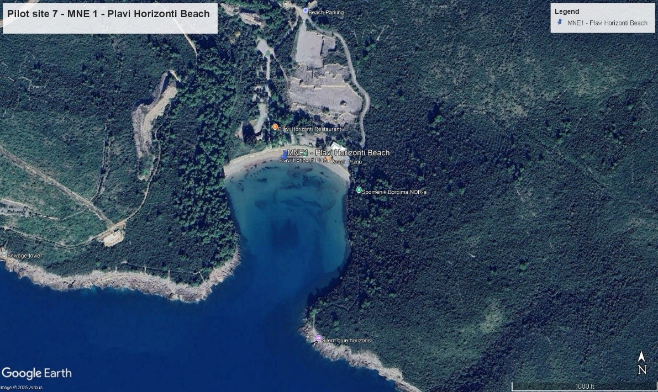
Location description: Enclosed-type beach, moderately rich in sediment, with moderate wave energy.
Survey area: Coastal zone in accordance with Section 2.1, from coordinates 42°23'3.16"N, 18°40'53.53"E to 42°23'2.50"N, 18°41'5.31"E.
- Jaz Beach
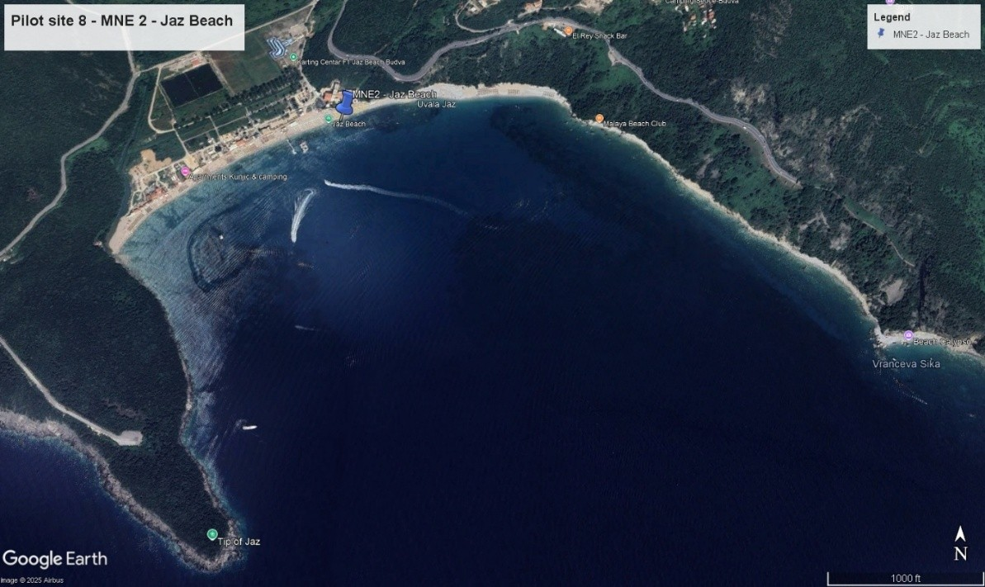
Location description: Sediment-rich beach with moderate to high wave energy.
Survey area: Coastal zone in accordance with Section 2.1, from coordinates 42°16'44.24"N, 18°48'1.93"E to 42°17'0.11"N, 18°48'51.24"E.
- Ričardova Glava Beach
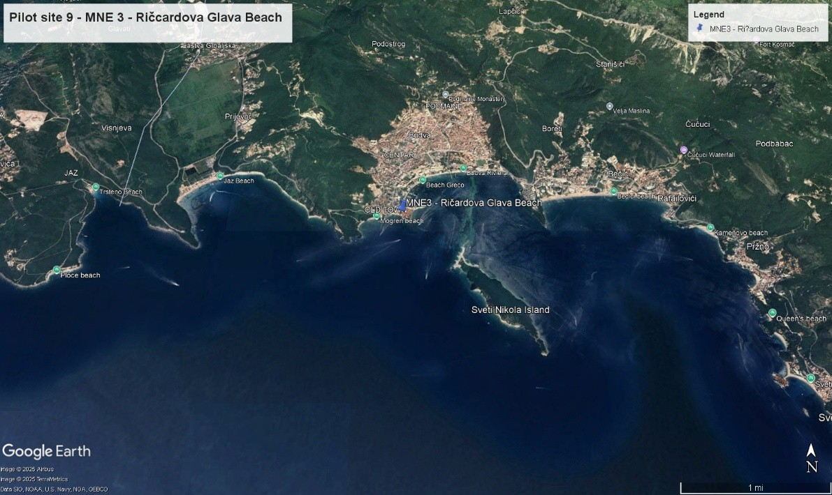
Location description: Beach with limited sediment supply and moderate to high wave energy.
Survey area: Coastal zone in accordance with Section 2.1, from coordinates 42°16'38.96"N, 18°50'8.15"E to 42°16'39.05"N, 18°50'14.02"E.
- Pizana Beach
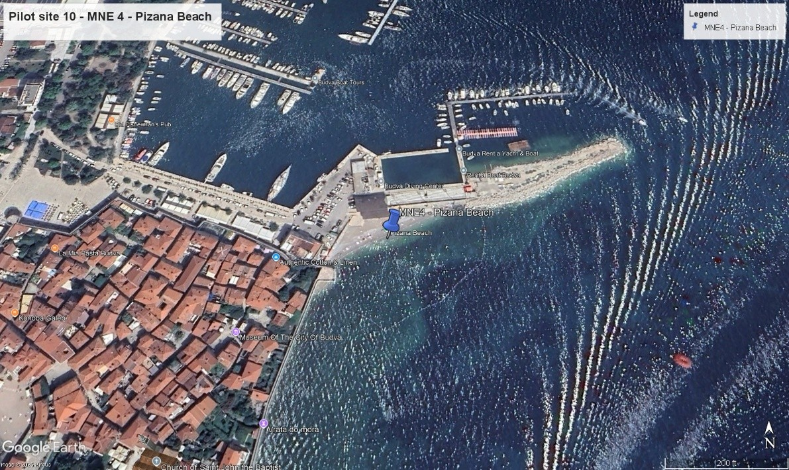
Location description: Beach with limited sediment supply and moderate to high wave energy.
Survey area: Coastal zone in accordance with Section 2.1, from coordinates 42°16'42.25"N, 18°50'21.42"E to 42°16'43.46"N, 18°50'25.19"E.
- Utjeha Beach
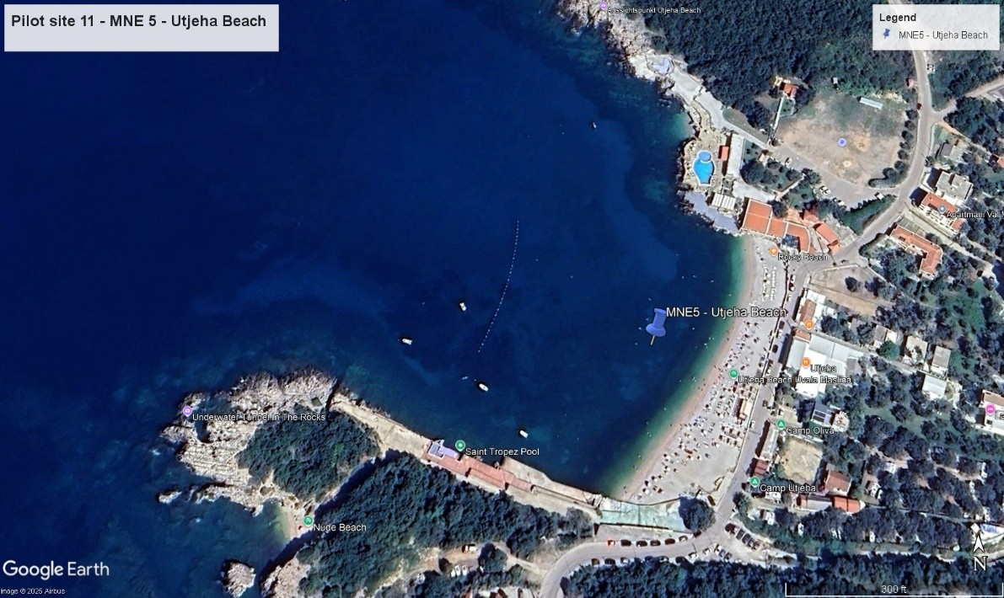
Location description: Moderately sediment-rich beach with moderate wave energy.
Survey area: Coastal zone in accordance with Section 2.1, from coordinates 42°0'41.40"N, 19°9'2.52"E to 42°0'36.61"N, 19°8'58.12"E..
- Veliki Pijesak Beach
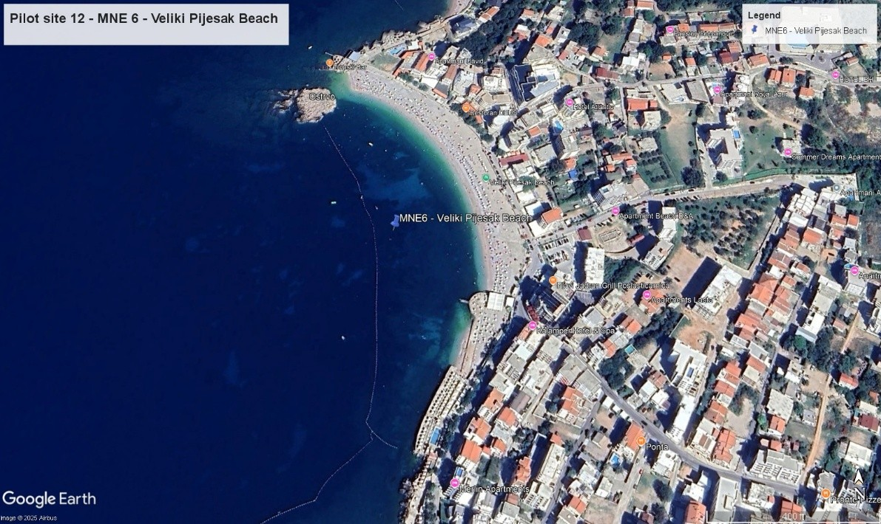
Location description: Moderately sediment-rich beach with moderate wave energy.
Survey area: Coastal zone in accordance with Section 2.1, from coordinates 42°2'8.79"N, 19°8'25.90"E to 42°2'0.41"N, 19°8'32.06"E.

Conditions for survey implementation and technical requirements

The Contracting Authority shall notify the Contractor electronically at least 10 days in advance of each survey cycle, within which the Contractor shall mobilise and commence field surveys for each cycle at all six locations. The Contractor shall carry out the second part of each cycle (after the wave event) at all six locations no later than seven (7) days after completion of the first part of the cycle (prior to the wave event).
The total number of survey cycles is five (5), in accordance with Section 4.2.1.
In addition, prior to the five survey cycles, the Contractor shall conduct one (1) reference survey of all six locations to establish baseline beach conditions. The reference survey represents a separate, initial survey and is not included in the five (5) survey cycles.
The service shall include costs of transport, equipment use, field work and data processing. For the execution of surveys, the Contractor shall obtain all required permits, approvals and other prerequisites necessary prior to survey implementation.

Following aerial surveys, image projection centres obtained through processing of GNSS observations from the UAV shall be assigned to each image. The aerotriangulation process consists of loading images and approximate coordinates of projection centres, defining camera parameters and the coordinate system using appropriate software tools.
Processing and results of aerotriangulation shall be provided as an annex to the Report, including external and internal camera orientation parameters and triangulated coordinates of tie points. Adjustment shall be performed based on all available airborne and terrestrial measurements (GNSS base data, terrestrial measurements of control points), while check points shall be used for accuracy assessment and control.

Technical requirements and expected outputs

Classified point cloud

A point cloud represents a three-dimensional set of points, where each point, in addition to spatial position, contains colour information. The point cloud shall be generated from the acquired imagery. The density of the generated point cloud shall be adequate for volumetric analysis requirements. The point cloud shall be classified into the following classes:
- terrain (including supratidal and submerged parts of the beach in accordance with Section 2.1)
- high vegetation
- roads
- buildings/structures
- other
The classified point cloud shall be delivered in *.las format, with classifications according to the defined classes.

Digital Terrain Model (DTM)

The Digital Terrain Model represents a 3D representation of the terrain class defined in Section 4.2.4.1.

The Digital Terrain Model shall be delivered in raster format (e.g. GeoTIFF) with appropriate spatial resolution and georeferencing.

True Digital Orthophoto (TDO)

The digital orthophoto map shall be produced by transforming images from central to orthogonal projection using an up-to-date DTM of appropriate quality and accuracy. Orthorectification is a digital image processing procedure that removes geometric distortions caused by perspective, terrain relief and similar effects. The production shall result in a true orthophoto. During mosaicking, tonal and colour corrections shall be applied, solar reflection effects neutralised, contrast within images equalised, and tonal transitions between images smoothed through seamless joining.

Digital orthophoto maps shall be delivered in GeoTIFF format (georeferenced *.tif).

Quantification of volumetric changes at beaches

Calculation of sediment volume changes at beaches shall be carried out by comparison with previous survey cycles. Quantification shall be delivered as an annex to the Report in graphical form.

Results of volume change calculations shall be georeferenced in the same coordinate system and aligned so that georeferencing remains identical throughout all survey cycles, enabling direct comparison of identical points between measurements. Data shall be delivered in digital format compatible with GIS analysis..

Project management

Responsible body
CLIMBEACH project team within Public Enterprise for Coastal Zone Management of Montenegro.

Management structure
The service contract “Photogrammetric Survey and Volumetric Change Analysis of Pilot Beaches in Montenegro (Budva)” will be implemented within the ClimBeach project (Interreg VI-A Croatia – Bosnia and Herzegovina – Montenegro 2021–2027). Overall project coordination, including legal and financial responsibility for implementation, is ensured by the Lead Partner (LP) University of Split, Faculty of Civil Engineering, Architecture and Geodesy (UNIST-FGAG).
Project implementation is supported by the Project Management Unit (PMU) established at LP level and composed of:
- Project Manager (PM) – responsible for thematic coordination of project activities and work packages (WPs), coordination between partners, monitoring progress against the project dynamic plan, and ensuring timely delivery of outputs. The PM is the primary coordination point for technical alignment of the contracted services with ClimBeach objectives and deliverables.
- Financial Manager (appointed by LP) – responsible for financial follow-up, budget monitoring, payment claim coordination, and ensuring compliance with programme and project financial rules relevant to this contract.
- Communication Manager (appointed by LP) – responsible for coordination of visibility and communication requirements related to project outputs, as applicable to the contracted services and deliverables.
The contract is implemented under the responsibility of the partner(s) in charge of the relevant Work Package, with WP2 led by UNIST-FGAG and the University of Montenegro, Faculty of Civil Engineering (UNIMO-FGAG). A designated WP responsible person will act as the operational focal point for this assignment and will: i) coordinate and monitor progress of the assignment in line with the ToR and project schedule; ii) organize, collect and perform quality control of deliverables prior to submission to LP; iii) coordinate inputs and support from other partners involved where relevant; and iv) promptly inform LP and partners of any circumstances that may affect scheduling, data collection, or delivery of outputs.
A Project Steering Committee (PSC), composed of two representatives from each project partner, provides strategic oversight of project implementation. PSC meetings are held at least once per project period (typically in the last quarter) to review progress, risks, and mitigation measures. Issues that may impact this service (e.g., access to pilot sites, timing constraints, data availability, or methodological alignment) may be escalated to the PSC through the PM/WP responsible person.
Coordination and communication: The contractor will cooperate with the PM and the designated WP responsible person through online coordination meetings (normally every two months or more frequently if required by implementation needs). Day-to-day communication will be carried out via email and agreed instant communication channels.
Data sharing: All documents, datasets, and deliverables related to this assignment (including raw and processed outputs, metadata, and reports) will be exchanged and archived via a shared cloud repository (e.g., Google Drive or an equivalent platform) as defined by LP, ensuring controlled access and traceability.
External support: LP may engage external expertise for project-wide management support (planning, reporting coordination, and PSC decision-making support). Where relevant, this support may contribute to ensuring that the contractor’s outputs are harmonized with project reporting requirements and WP deliverable standards.

Facilities to be provided by the contracting authority and/or other parties
Facilities will be provided by the contractor.

LOGISTICS AND TIMING

Location
Place of performance as described under point 4.2.2.

Start date & period of implementation of tasks
The intended start date is 30 April 2026 and the period of implementation of the contract will be 12 months from this date. Please see Articles 19.1 and 19.2 of the special conditions for the actual start date and period of implementation.

REQUIREMENTS

Personnel
Note that civil servants and other staff of the public administration of the partner country, or of international/regional organisations based in the country, shall only be able to provide input as experts if well justified. The justification should be submitted with the tender and shall include information on the added value the expert will bring as well on any potential interference or conflict of interest of the proposed expert in his/her function as expert and his/her present or previous functions working as civil servant. Moreover proof should be submitted that the expert is seconded or on personal leave.
The selection procedures used by the contractor to select the experts who provide input to the contract must be transparent, must guarantee the absence of professional conflicting interests and the absence of any discrimination based on former or current nationality, gender, place of residence, or any other ground. The findings of the selection panel must be recorded.
All experts must be independent and free from conflicts of interest in the responsibilities they take on.

Experts
Minimum requirements for experts are not defined.

Support facilities & backstopping
The costs for support facilities, including backstopping, are included in the tenderer's financial offer.

Office accommodation
Office accommodation for each expert providing input to the contract is to be provided by the contractor.

Facilities to be provided by the contractor
The contractor shall ensure that experts are adequately supported and equipped. In particular it must ensure that there is sufficient administrative, secretarial and interpreting provision to enable experts to concentrate on their primary responsibilities. It must also transfer funds as necessary to support their work under the contract and to ensure that its employees are paid regularly and in a timely fashion.

Equipment
No equipment is to be purchased on behalf of the contracting authority / partner country as part of this service contract or transferred to the contracting authority / partner country at the end of this contract. Any equipment related to this contract which is to be acquired by the partner country must be purchased by means of a separate supply tender procedure.

REPORTS

Reporting requirements
The Contractor shall submit:
- Prior to the five survey cycles, the Contractor shall conduct one (1) Reference survey of all six locations to establish baseline beach conditions. The reference survey represents a separate, initial survey and is not included in the five (5) survey cycles

- Reports on performed work to the Contracting Authority after completion of each cycle for all locations, within 15 days from completion of each survey cycle. The Report shall include graphical and textual data from all preceding sections. Annexes to the Report shall include digital records defined in Section 4.2.4. All obtained permits shall be attached as annexes to the Report. The Report for each survey cycle shall include evidence of execution of the cycle at all six locations and shall present the equipment used and methodology applied. The Report shall contain results of processing of baseline and final surveys for each of the five survey cycles at all locations.

Upon delivery of the Reports, the Contracting Authority shall review and approve the documentation within 30 days of submission. In the event of deficiencies, the Contractor shall be notified prior to approval. Approval of the Report constitutes a prerequisite for payment of the corresponding part of the invoice related to the cost items covered by the Report.
Reports shall be prepared using the template provided by the Contracting Authority in accordance with programme rules, which shall be made available to the Contractor upon contract signature.
Reports shall be submitted electronically, in Montenegrin and English, in accordance with programme rules.

Submission and approval of reports
The report referred to above must be submitted to the project manager identified in the contract. The project manager is responsible for approving the reports.

MONITORING AND EVALUATION

Definition of indicators
Progress towards achieving the expected results of this contract will be measured using the following indicators (quantitative and qualitative), applicable per pilot site and per monitoring epoch:
- Coverage of pilot sites
- Indicator: Number of pilot beaches surveyed in Montenegro.
- Target: 6/6 pilot beaches covered.
- Monitoring frequency / completion of survey epochs
- Indicator: Number of completed monitoring epochs per pilot beach (as specified in the ToR, including event-driven epochs where feasible).
- Target: 100% of planned epochs completed within the contract duration.
- Delivery of required geospatial outputs
- Indicator: Share of planned deliverables provided per site/epoch in the required formats (classified point cloud (.LAS), DTM (.LAS), true digital orthophoto (GeoTIFF), volumetric change outputs in GIS-compatible format, reports).
- Target: 100% of required deliverables submitted and complete.
- Georeferencing consistency and comparability across epochs
- Indicator: Evidence of consistent coordinate reference system and alignment across epochs enabling direct comparison (documented in metadata/QA-QC).
- Target: Full comparability across epochs confirmed during acceptance review (no systematic shifts between epochs).
- Volumetric change analysis produced
- Indicator: Number of epoch-to-epoch volumetric change assessments delivered per pilot beach, including maps/figures and numerical results (erosion/accretion volumes).
- Target: 100% of required change analyses delivered according to the defined epoch pairs.

Special requirements
N/A
* * *

